Project

Mid-Semester Report

|  |  |
| --- | --- |
| Document Information | |
| Course Title | Electronics Design I |
| Course Code | ELET 2405 |
| Date | October 9, 2023 |
| Student ID | 620157646 |

**Table of Contents**

**Chapter Page Number**

Introduction 3

Digital Clock Bill of Materials 4 - 6

Digital Clock Description and Specification 7 - 8

Digital Clock Design 9

Hardware Block Diagram 10

Hardware Schematic Diagram 11

Software State Diagram 12

Software Flowchart 13 - 16

References 17

**Introduction**

The idea of relative time, which may be seen differently by observers in motion relative to one another, was first articulated in Albert Einstein’s theory of special relativity in 1905. Humans have long sought a means to precisely measure and keep track of time ever since it was discovered. Although primarily focused on theoretical aspects of time and its relationship with space, Einstein's contributions significantly impacted our comprehension of clocks, time measurement, and their connection to the fundamental principles of the universe.

Unlike conventional analog clocks, which indicate time with hour and minute hands, digital clocks display the time in a numerical manner using digits. Digital clocks are used in a variety of settings including homes, businesses, public areas and technological gadgets because they give a clear and easy-to-read depiction of the time. The majority of digital clocks are microcontroller-based, which makes them more compact, effective, and functionally versatile than earlier models. The system will keep the value in memory and sound the alarm using the buzzer when the time has arrived. We may set the time to start at any hour, minute, or second. We can also set an alarm. The ATtiny2313A microcontroller, a dependable and programmable computational device, will be used in this project to regulate and show the time with a one second precision to a 16x2 Alphanumeric LCD display and to sound an alert using a buzzer.

**Digital Clock Bill of Materials**

|  |  |  |  |
| --- | --- | --- | --- |
| Table 1 – Equipment and Components Required for Digital Clock Project | | | |
|  | Items | Quantity | Price Per Unit ($) |
| Equipment: | Pololu AVR USB programmer or any other hardware programmer capable of programming 8-bits AVR microcontrollers. | 1 | 3,500.00 |
| Computer loaded with Microchip Studio 7 and KiCad. | 1 |  |
| Soldering Iron | 1 | 500.00 |
| Components | ATtiny2313A or ATtiny4313 AVR Microcontroller | 1 | 450.00 |
| 16x2 Alphanumeric LCD | 1 | 1,250.00 |
| LM7805 (+5V) Voltage regulator | 1 | 100.00 |
| 9V Battery | 1 | 738.83 |
| Red LED | 1 | 50.00 |
| Push Button Switch | 5 | 200.00 |
| 0.33 µF capacitor | 1 | 75.00 |
| 0.1 µF capacitor | 1 | 75.00 |
| 22 pF capacitor | 2 | 75.00 |
| 100 Ω resistor | 1 | 30.00 |
| 10k Ω resistor | 1 | 30.00 |
| Quartz Crystal Oscillator , between ( 8 – 20 MHz) | 1 | 100.00 |
| Sliding Switch(3 Pin) | 1 | 200.00 |
| 10kΩ Potentiometer | 1 | 200.00 |
| 1N4001 Diode | 3 | 75.00 |
| 20pin DIP Socket | 1 | 100.00 |
| 2 Pin Header (Male) | 1 |  |
| 16 Pin Header (Male) | 1 | 200.00 |
| 16 Pin Header (Female) | 1 | 200.00 |
| Buzzer | 1 | 200.00 |
| 2N3904 Transistor | 1 | 75.00 |
| Solder Wire | 3ft | 500.00 |
| PCB Clock Board | 1 | 500.00 |

Table showing the Equipment and Components for Digital Clock Project

**Digital Clock Description and Specification**

A digital clock is one that uses a display to show time in digital format. For this project, a 16x2 Alphanumeric LCD module will be used to display the. The display will allow six digits in the format of HH:MM:SS to be shown. The LCD is interfaced with ATtiny2313A microcontroller. The clock should be a compact, lightweight, handheld gadget that can execute the fundamental operations of a digital clock, such as setting the time or an alarm, resetting the time, and changing the time zone. In particular, it needs to be portable, be able to maintain precise timing with an accuracy of one second, and include five buttons: one to reset the time, one to set the time or an alarm, one to switch between modes, one to scroll to the left/up and one to scroll to the right/down.

**Operation:** The time will be displayed on the LCD screen after it has been set and will increment as time elapses. By utilizing the built-in delay feature, the seconds portion of the display will increase after each second. When the seconds part of the display reaches 59, the minutes part of the display will increment by one and the seconds part will reset to 0. Similarly, as the minutes part reaches 59, the hours part will increase by one and the minutes part will reset to 0. While in the 12 hour mode, after the hours part reaches 11, the minutes part reaches 59 and the seconds part reaches 59, the display will set to 12:00:00 and the AM/PM will change to PM/AM respectively. While in the 24 hour mode, after the hours part reaches 23, the minutes part reaches 59 and the seconds part reaches 59, the display will set to 00:00:00.

**Power Source:** The clock will operate primarily from the 110V JPS. A voltage regulator will be used to step down the voltage to 5V to power the circuit. Additionally, the clock will feature a battery backup to ensure continuous operation in the event of a power outage.

**Mode:** This digital clock will operate in both 12 and 24 hour modes. The user will be able to switch between modes by pressing a button. This is configured by programming the ATtiny2313A microcontroller. The software will utilize the built-in delay function and oscillator to create a delay of one second.

**Set Time:** The user will be prompted to set the time on the LCD display after pressing the set button. The user will only be able to adjust the clock's hours and minutes by repeatedly pushing the corresponding switch until the desired values are achieved.

**Reset:** Depending on whether the clock is set to the 12 hour mode or the 24 hour mode, the default time when the reset button is pressed is 12:00:00 or 00:00:00, respectively.

**Set Alarm:** The user will be prompted to set their desired alarm time on the LCD display after the set alarm button is pressed. Only the hours and minutes of the clock may be adjusted by the user, and this would be done by repeatedly pressing the corresponding switch. After setting the alarm, when the clock display matches the desired time, the buzzer will begin to ring constantly for a predefined amount of time or until the user silences the alarm by pushing one of the buttons.

**Digital Clock Design**

To satisfy the aforementioned requirements, a Hardware Block Diagram was made to provide a basic understanding of some of the important components that would be interfaced with the ATtiny2313A microcontroller. The KiCad 7.0 program was also used to generate the hardware schematic diagram.

**Hardware Block Diagram**

A potential block diagram for the digital clock is shown in the image below. Here, an LCD serves as the display, a microcontroller serves as the brain, and buttons serve as input devices. The quantity of I/O lines required to connect to the microcontroller and the power supply required for operation are also displayed. To guarantee that the following requirements are fully satisfied, the Digital Clock Hardware Block Diagram is utilized to identify the precise parts that will be connected to and interacted with the microcontroller.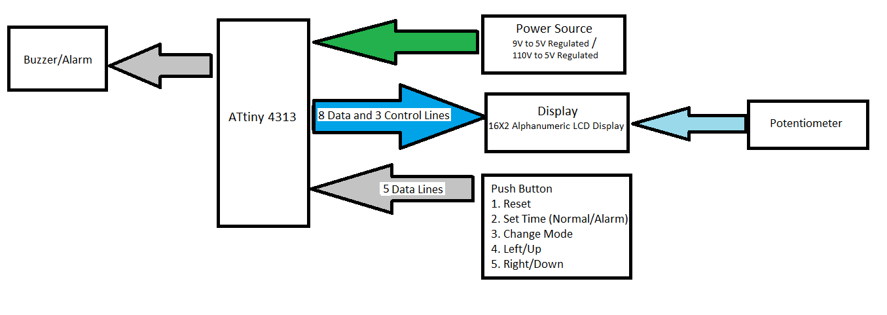

Change Value

Change Mode

Set Alarm

Set Time

Reset

ATtiny2313A

Figure showing Digital Clock Project’s Block Diagram

**Hardware Schematic Diagram**

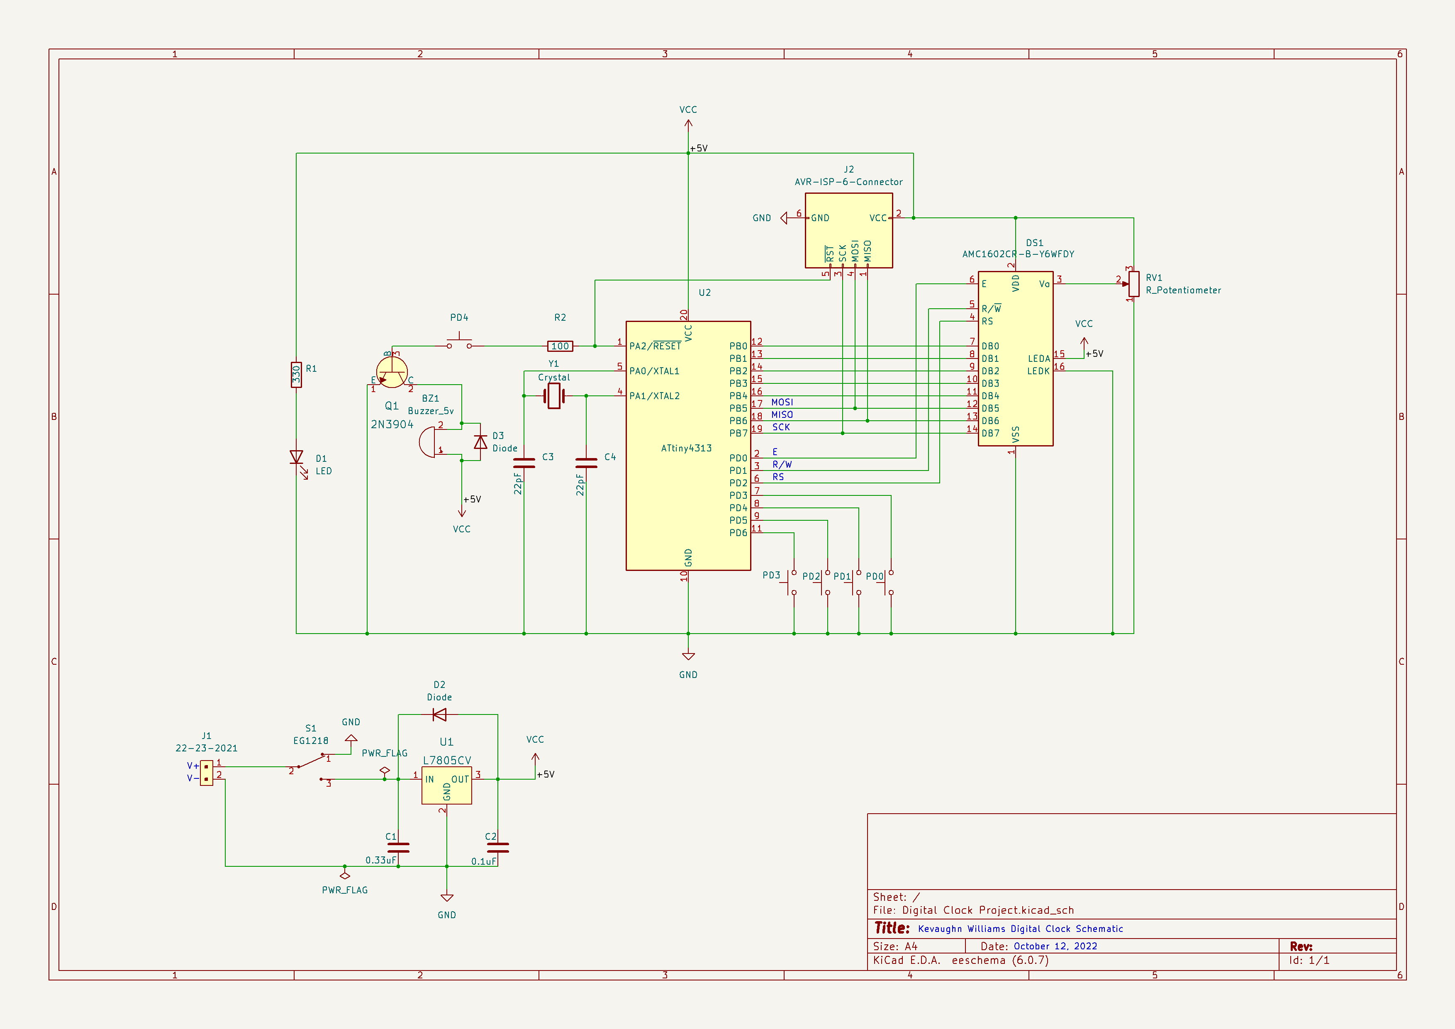

ATtiny2313A

Figure showing Digital Clock Circuit Schematic Diagram with Power Supply

**Software State Diagram**

Normal Clock State (SW1) Pressed

Change Mode (SW2) Pressed

Normal Clock State (SW1) Pressed

Set Time (SW3) Pressed

Normal Clock State (SW1) Pressed

Set Alarm (SW4) Pressed

Motivational Message (SW7) Pressed

Normal Clock State (SW1) Pressed

Normal Clock State (SW1) Pressed

Normal Clock State (SW1) Pressed

Disable Alarm (SW5) Pressed

Snooze (SW6) Pressed

**Software Flowchart**

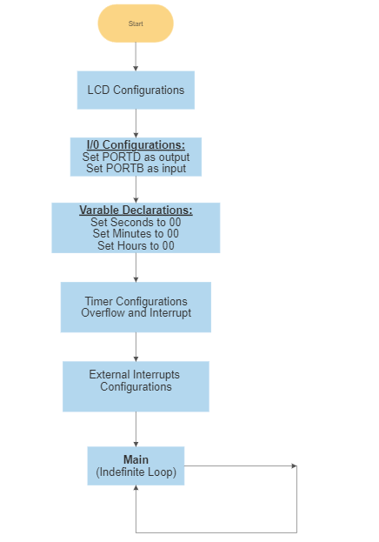

Figure showing general operations of Digital Clock

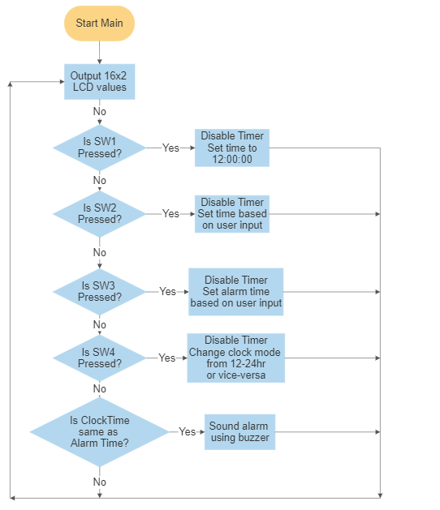

Figure showing logical operations of Digital Clock

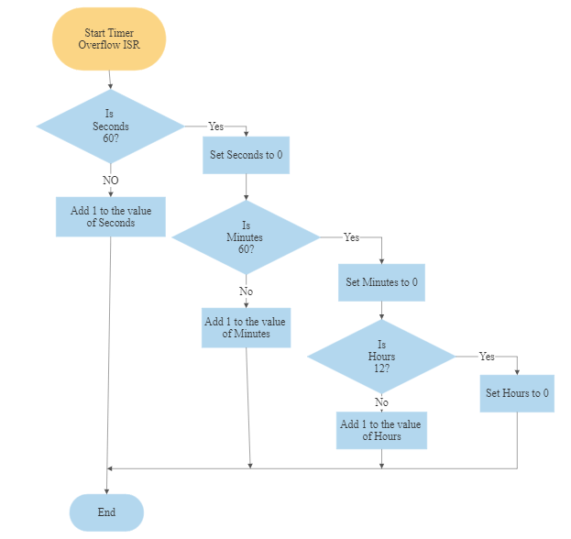

Figure showing Interrupt Service Routine for Digital Clock in 12 Hour mode

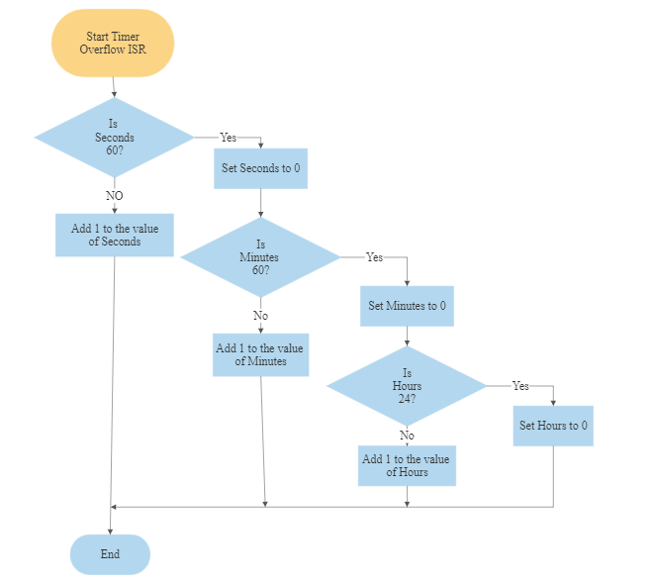

Figure showing Interrupt Service Routine for Digital Clock in 24 Hour mode

**References**

ELET2405 Experiment 3 (2023)

ELET2405 Information Sheet

OpenAI. (2023, October 1). Conversation with ChatGPT [Chat conversation].